SEAN O’GORMAN – G00314259

Mobile Application Development

Project design document

Table of Contents

Overview 2

Game Design 3

Map 3

Tiles 3

Health & Food 3

Movement 3

Objectives 3

Pages 4

Intro Screen 4

Main Menu 4

New Game 4

Load Game 4

Check Scores 4

Level 1/2/3 4

# Overview

For my project, I have decided to create a tile-based exploration game.

Simple, fun games with low time-commitment have become extremely popular on smartphones, as they are convenient to play during short moments of downtime.

Below is first rough outline of my idea for Seas of Wrath, a game based on survival through the harsh seas, and the acquisition of wonderous treasures.

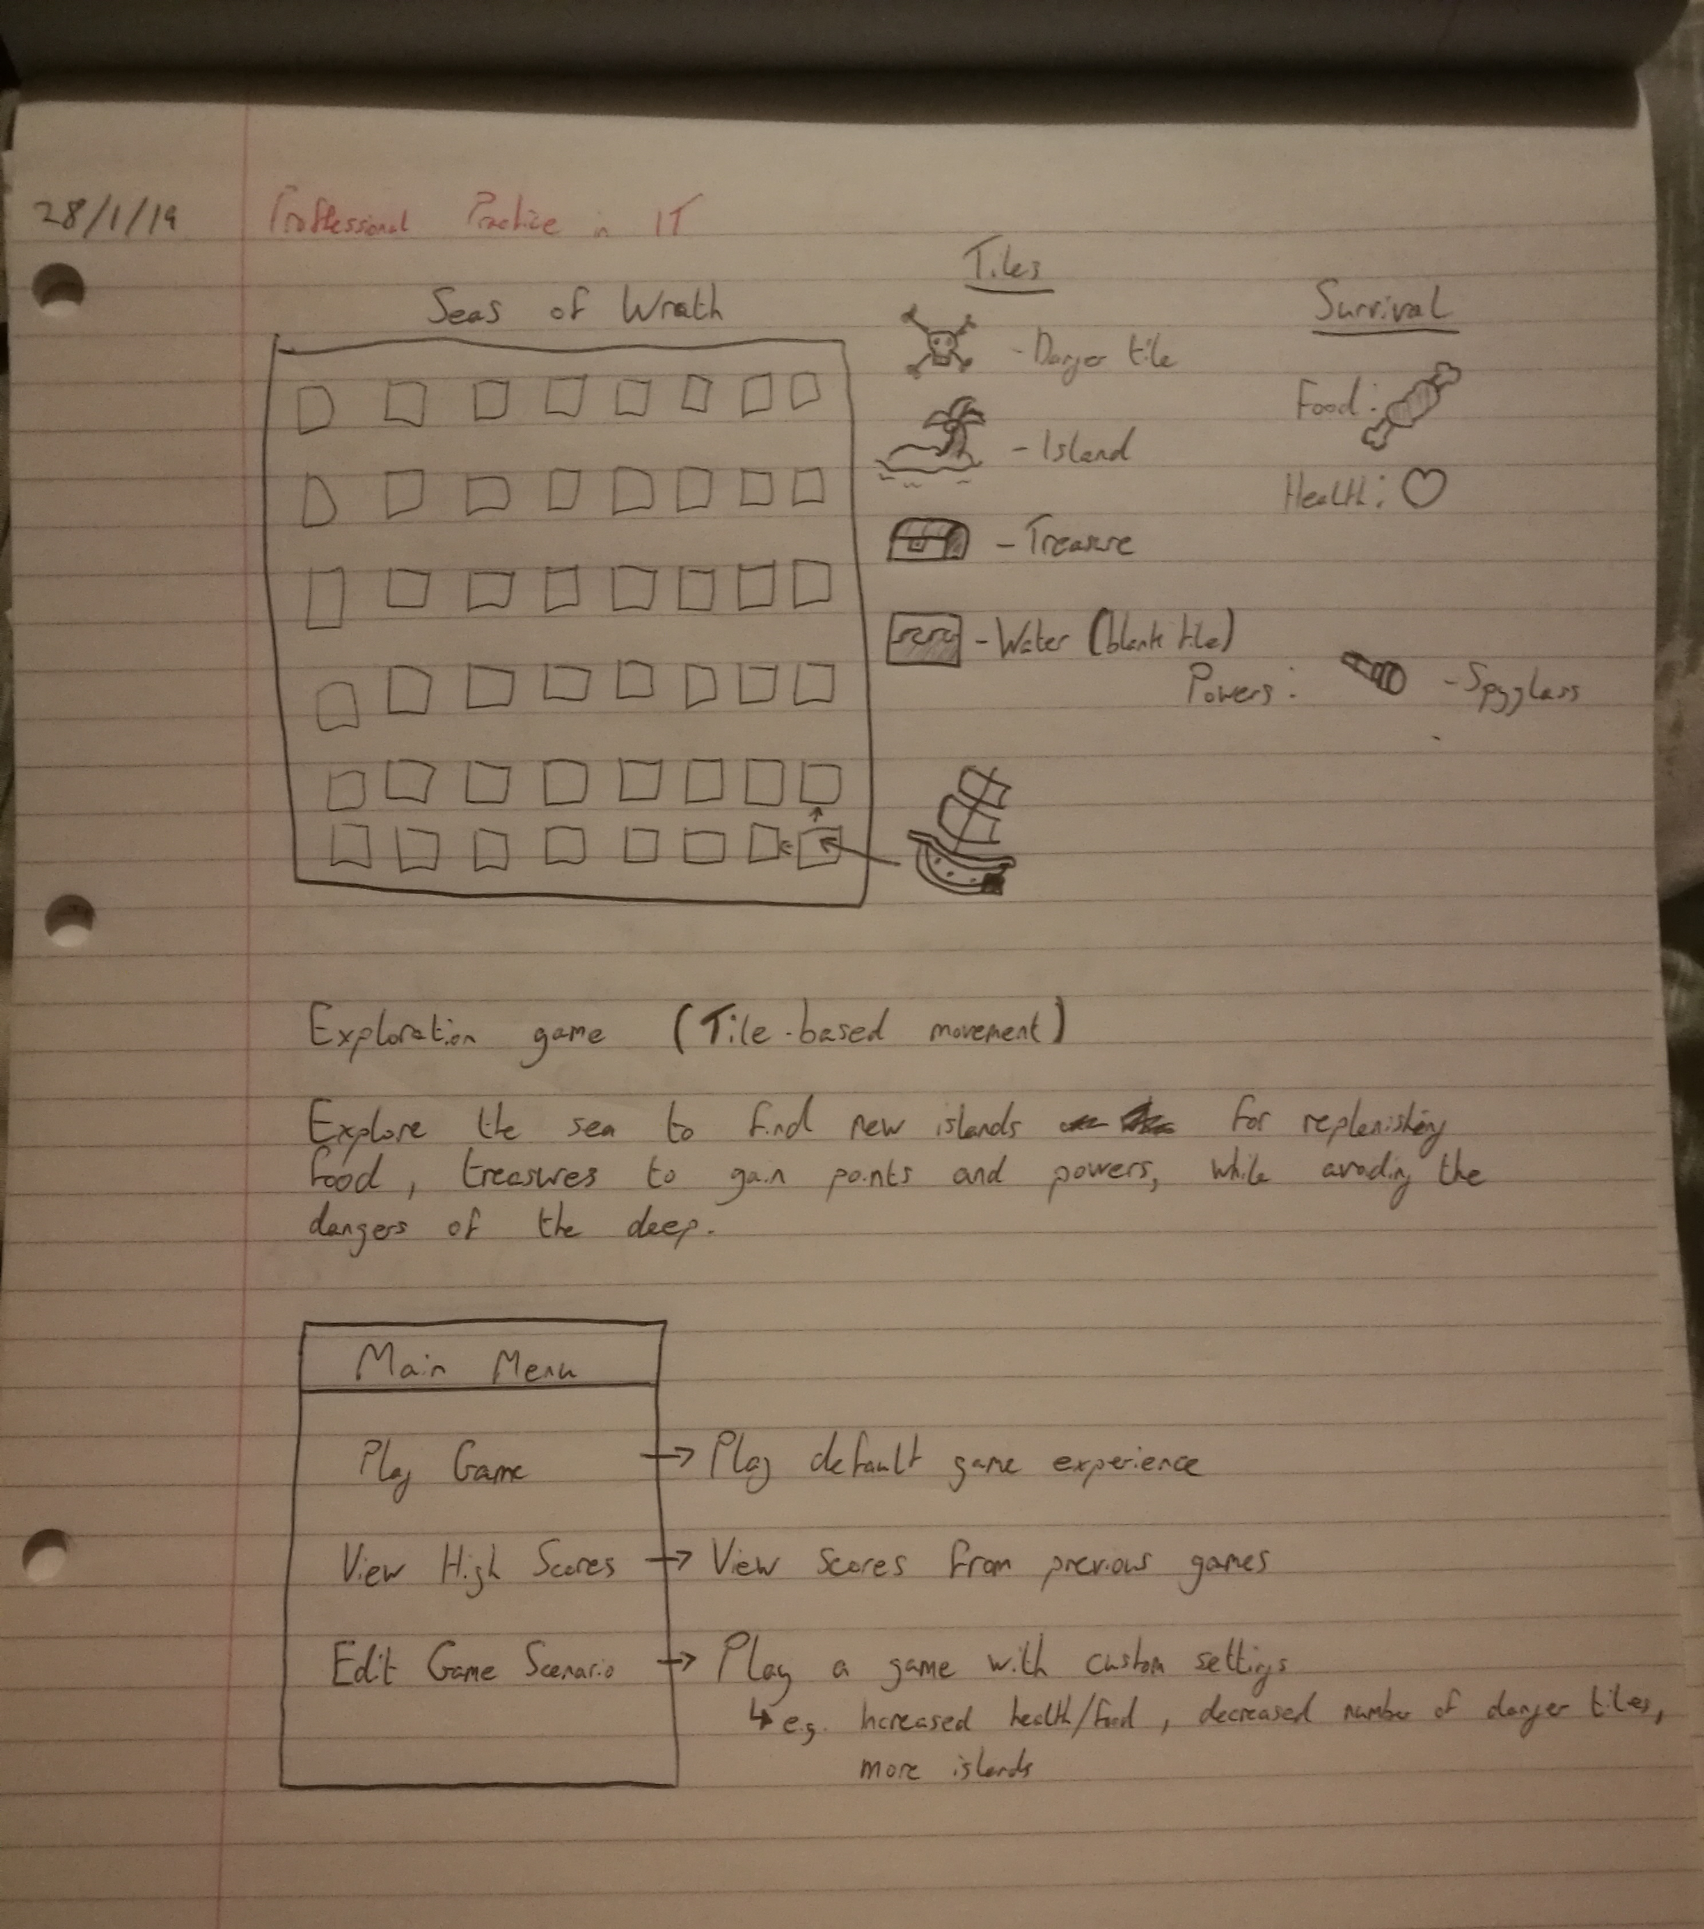

# Game Design

## Map

The game will begin with a picture of a ship in the bottom corner of the game grid. The rest of the tiles on the map will be empty. Though they are not initially visible, the map will be populated with danger tiles, island tiles, treasure tiles and water tiles. Each of these tiles have a different effect when sailed over.

## Tiles

The **danger tile** displays a skull representing a danger that can damage your ship, reducing its health by 1 if you sail over it.

The **island tile** is a place for the ship to rest, and where you can replenish your food stocks.

The **treasure tile** is where you’ll find great riches, which increases your score.

The **waves tile** is simply an empty patch of ocean which won't have any effect on your ship.

## Health & Food

These are the stats that keep your ship & crew alive. Health is reduced by danger tiles, and food is reduced with each movement of the ship. Reaching zero in either of these will result in a game over.

## Movement

Each turn will be divided into two parts, “check” and “explore”.

During the check phase of the turn, the player can choose any adjacent tile to reveal what is hidden there. Then, it is time to explore. The player chooses which direction to move in, though this does not necessarily have to be in the same direction that the player checked. In this way, the player must take calculated risks on whether or not they should move into unknown territories in order to avoid revealed dangers, or retreat backwards at the risk of running out of food.

## Objectives

The aim of the game is to manoeuvre from one side of the grid to the other, while avoiding dangers and collecting treasures along the way. Scores can be maximised by accomplishing this in as few turns as possible.

# Pages

## Intro Screen

Upon starting the application, the first page will be a simple introduction screen with the name of the game. Pressing on the screen will bring the user to the main menu.

## Main Menu

This page will contain a short list of the main available options ‘New Game’, ‘Load Game’ and ‘Check Scores’

## New Game

This page will allow the user to select from a list of levels to play.

## Load Game

The user will be able to load a previously save game from this list.

## Check Scores

This page will show the statistics from the previous times that they have played the game.

## Level 1/2/3

These pages will be where the game itself is played